8 BIT DIVISION

# EXP NO: 04

# AIM:

# To write an assembly language program to implement 8-bit Division using 8085 processor.

# ALGORITHM:

1. Start the program by loading the first data into the Accumulator.
2. Move the data to a Register.
3. Get the second dada and load into the Accumulator.
4. Add the two Register contents.
5. Check for Borrow
6. Store the result in the memory location
7. Halt.

# PROGRAM:

LDA 4500

MOV B,A

LDA 4501

MVI C,00

LOOP: CMP B

JC LOOP1

SUB B

INR C

JMP LOOP

LOOP1: STA 4502

MOV A,C

STA 8503

RST 1

INPUT:

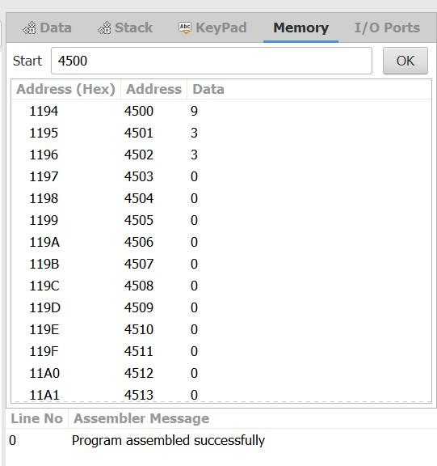

OUTPUT:

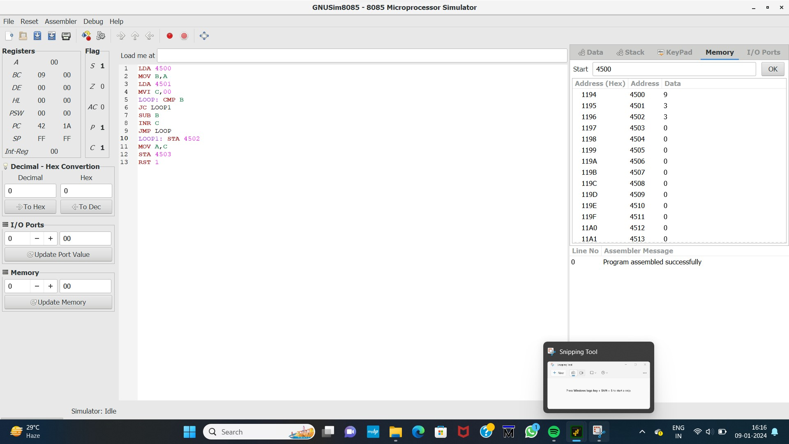

RESULT: Thus the program was executed successfully using 8085 processor stimulator.